**Supplementary material 2**

We sought to investigate whether clearfell forestry operations influenced the relative risk of a bTB breakdown on nearby farms. We were particularly interested in whether this effect varies as a function of time, i.e the time lag between the date of a clearfell and the date of a positive test on local farms (temporal scale), and the distance between the clearfell and the farm (spatial scale). To compute the time lags we followed annual 12 month ecological cycles (0-12/12-24/24-36 months) as opposed to gregorian calendar cycles (a year defined as January-December) from the first detection or last clear test of bTB following a clearfell. This ensured that detections were not mis-classified by calendar dates (i.e December 2015 is not connected to January 2016), rather, we could examine the full effect of time over the course of 12 months. The computation of the time lag was dependent on the bTB history of the farm. For bTB positive farms in 2017, we computed the time difference in months between a clearfell and the first detection (positive test) of bTB. For bTB negative farms, we computed the time difference in months between the clearfell and the latest negative test result for that farm. These computations were run for every clearfell during the study period and connected to farms via the spatial buffers.

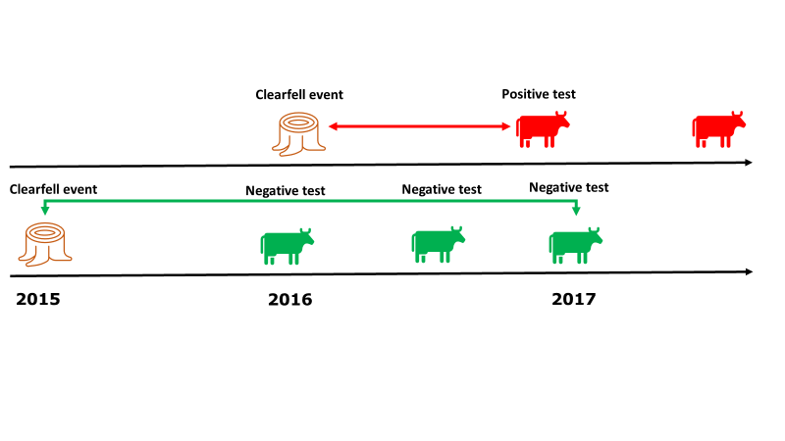

**Figure 1: Infographic describing the calculation of time lags between a clearfell event and bTB positive or negative farms. The top row depicts how the first detected positive test after a clearfell is associated with that event. In contrast, the second shows how the latest negative test is associated with the clearfell event. All computations were run within each of the six spatial buffers. See body text for full details.**

We thus selected cattle herds that were either positive or negative to bTB in 2017 but tested negative in both 2015 and 2016. In doing so, we could disentangle whether clearfell operations that occurred in the previous 2 years had a time-lagged effect on bTB outbreaks recorded in 2017. We also computed area data for clearfell operations and habitat types within distance buffers around farms (ranging from 1 km to 6 km).

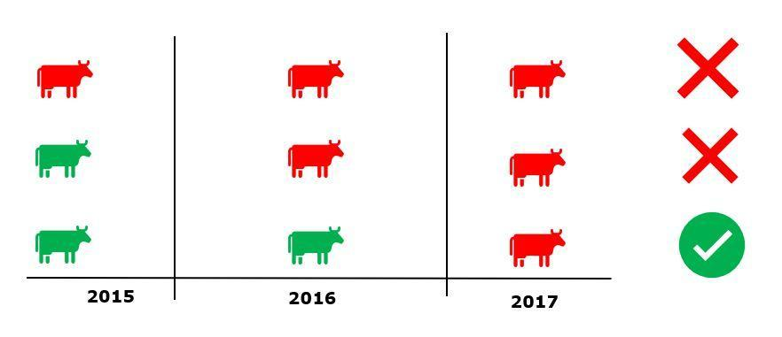

**Figure 2: Infographic describing farms which match our criteria for inclusion in the study as case farms (red: positive bTB test; green: negative bTB test)**

Out of the 104,017 farms that met the criteria described above, 1,736 farms tested positive for bTB in 2017 (1.6%) in contrast to 102,281 negative case farms. We used a case:control sampling design by fitting a conditional logistic regression model (full details can be found by readers in the main paper) using the *survival* package to analyse the data (Therneau, 2021). We matched positive farms (case) with negative farms (control) within a 25 km radius *a priori* selected in order to compare farms within similar macro-ecological conditions.

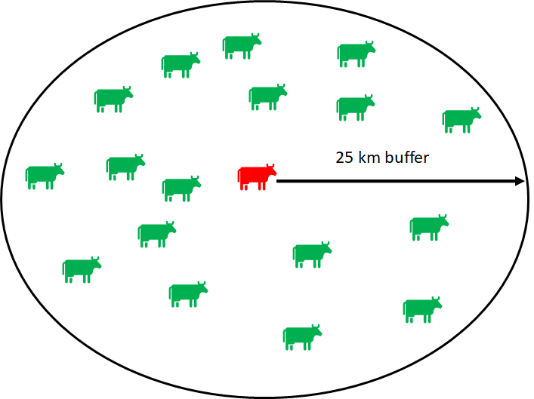

**Figure 3: Infographic describing case:control selection.**

We ran a sensitivity analysis and selected a case:control ratio of 1:20 (bTB positive:bTB negative) to guarantee that model coefficient estimates were stable (see Fig. 4). We selected this ratio by running samples of 10 logistic regression models with our model structure containing 1 to 20 control farms, each time randomly selecting a new set of control farms. For each sample we saved the predictor coefficients in a database. We then used generalised additive regression models using the *gam*  functionfrom the *mgcv* package (Wood 2006) to plot the logistic regression coefficients of each predictor to examine when the coefficients stabilised, i.e the spline flattened due to reduced variability.

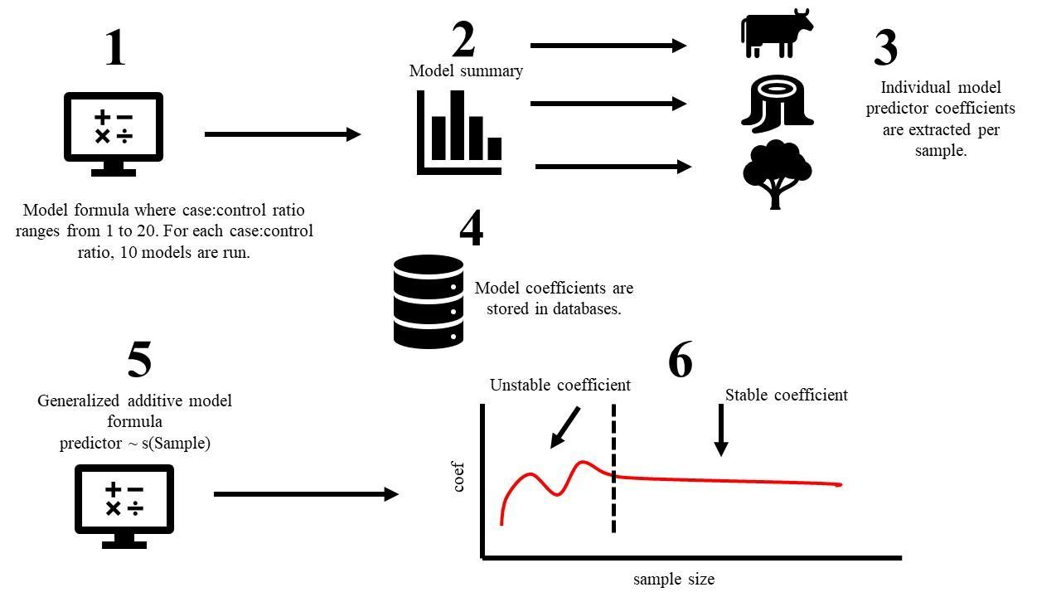

**Figure 4: Infographic describing case:control sensitivity analysis.**

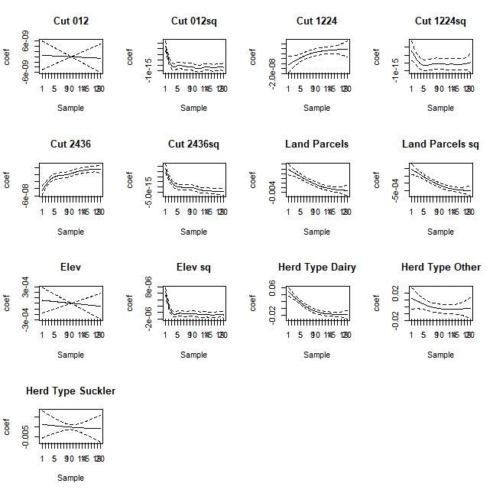

**Figure 5: Generalised Additive model splines to examine the stability of model coefficients for case:control structure (as estimated by conditional logistic models matching case positive farms vs control negative ones). The x-axis shows the number of control farms included in the sample, ranging from 1 to 20. The y axis represents the predictor coefficient for the model containing x number of controls. Cut represents area (in hectares) of clearfell and the numbers represent the time lag (0-12, 12-24, 24-36 months). Land parcels represent the number of individual land fragments per farm. Elev represents the elevation (in metres). Herd type represents the type of business the farm operates. Sq represents the quadratic effect of each predictor variable included in the model.**

For many of the predictors we achieved stability of the coefficients after including <= 10 control farms. However, some predictors stabilised later (see land parcels in figure S2.5 second row, second from the right). As we had access to more control farms and to ensure optimum stability, we opted to include 20 control farms for every case farm (but we decided not to add further control cases >20 on the basis of our sensitivity analysis).